**Mid-Semester Assignment**

Steps for Creating Kiteretsu Cartoon Characters in GIMP:-

Step 1: Choose an image from internet to draw.

Step 2: Start tracing the image using Pencil tool in a new Transparent layer using GIMP.

Step 3: Remove the Layer of photo which is added for tracing.

Step 4: Create a new Layer to fill the colours in the traced image.

Step 5: Start filling colour by zooming the image to fill the colours by detailing.

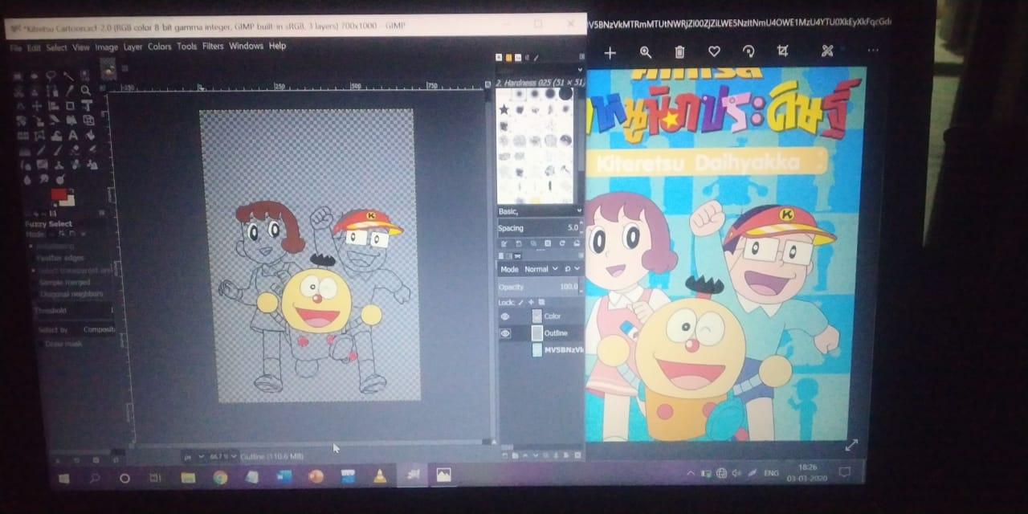

Step 6: Now start using the Fuzzy Select tool to select the area, and start filling the colours in that areas (It makes work so easy).

Step 7: Now, Fill the colour in background by applying the same mechanism.

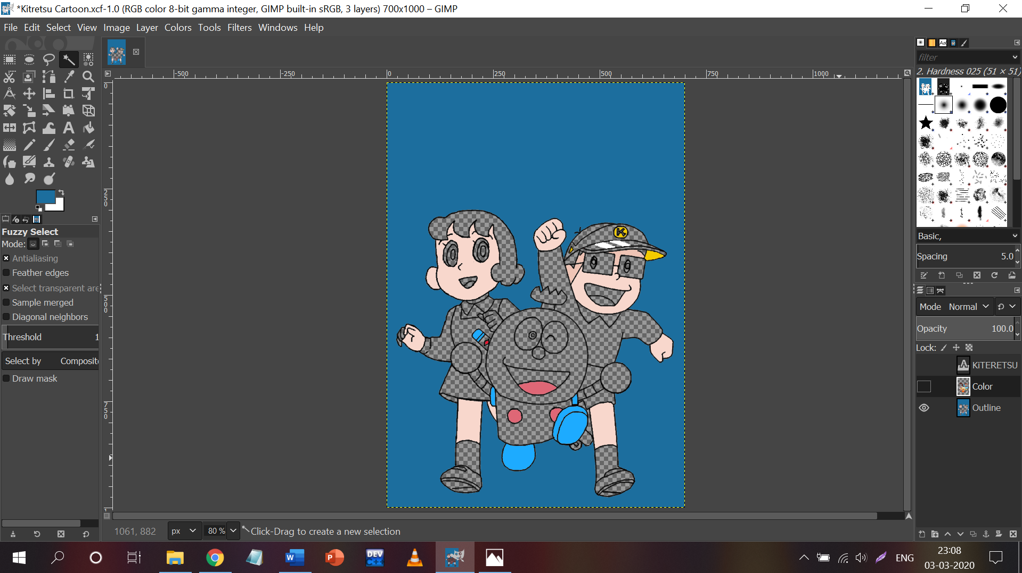

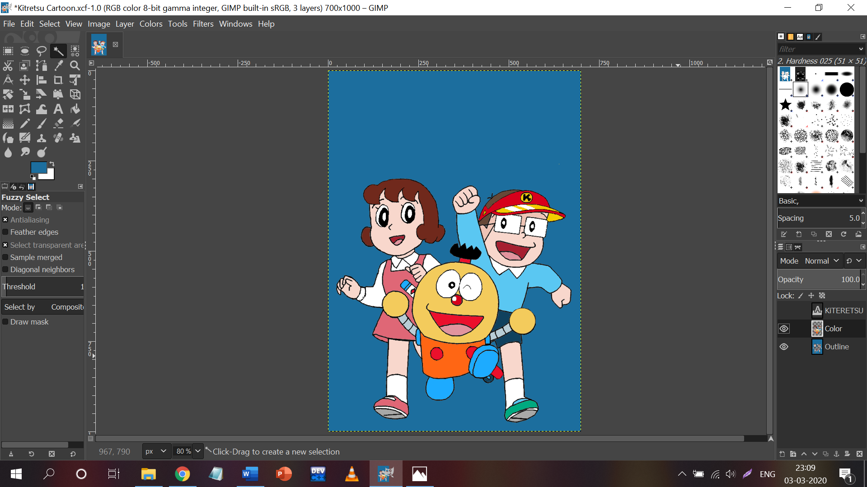

Step 8: Now, write the title of the image(Kiteretsu) using **“Segoe Print”** Font.

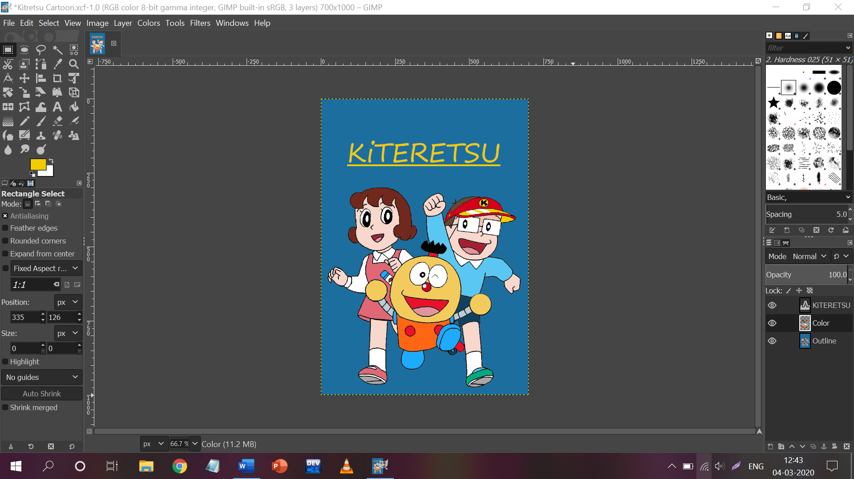

Step 9: Now, the final Image is ready.

Step 10: Now, Export the final image in .**png** format.

